Java Swing – An introduction to User Interface: Events

Events

Designing an application is cool, but having a functional app is even better.

Unlike regular programming in which the computer decides when to run things, user-oriented programs are exactly that – run by the user. We call this kind of programming Event-driven programming.

We’ve seen this before in Scratch. When you press a button or press a key or click your mouse, it does something.

In order to catch an event, we need to have something called LISTENERS – things active in the background “listening” to an event.

Some Listeners we’ll deal with:

* ActionListener
  + ActionEvent
* ItemListener
  + ItemEvent
* MouseListener
  + MouseEvent
* MouseMOtionListener
* KeyListener
  + KeyEvent

Some basic ideas:

* Listeners are objects: they require programming and are a class in itself
* The source object must add listeners: unless we tell a component to listen, it won’t listen for anything
* Most listeners are programmed specifically for one UI. Having multiple files for one interface doesn’t make too much sense, so we create INNER CLASSES.
  + These classes exist only inside the realm of the Larger class.   
    BE CAREFUL. INNER CLASS DOES NOT EQUAL SUBCLASS
* These listeners you will create not subclasses to the Listener classes, but use the IMPLEMENT word (implies an interface)

# Example - ActionListener

Let’s see it in action.

**Take a look at DemoActionListener.java.**

For multiple buttons, we can create multiple listeners:

**Take a look at DemoActionListener1.java.**

Or create one listener and use the .getSource() function.

**Take a look at DemoActionListener2.java.**

# General

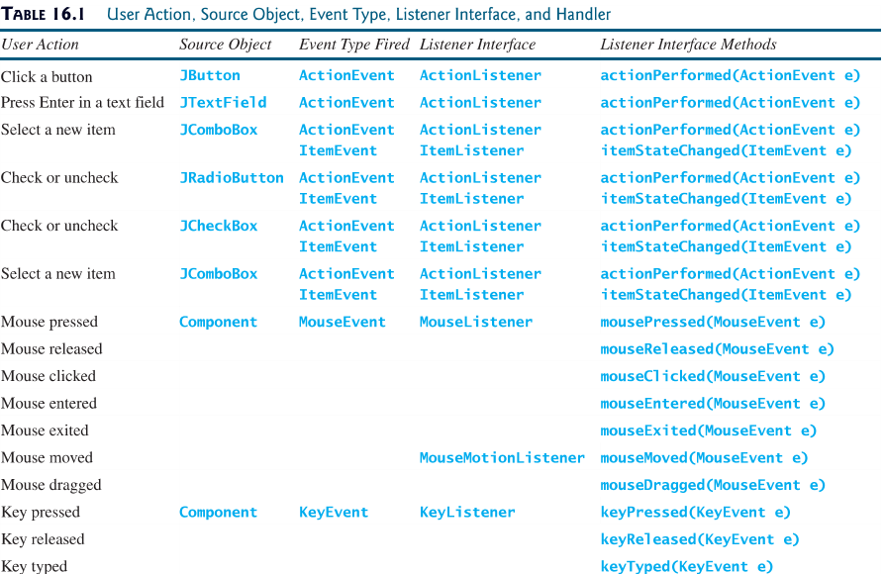

## **Notice: that when you create a Listener, you must have all the methods, even if you don’t use them.**

## Practise

1. Edit the ActionListener to also have a MouseListener:
   1. When the mouse is pressed on a button, change its colour
   2. When the mouse is released, change the colour back
2. Create a textfield, that when you press enter , the Font changes
3. Create a text field and have it only accept numbers as input (keyEvent).